Lab # 10
JUnit Testing
OBJECTIVE: Study the concept of Test Driven Development under the framework of JUnit Testing.
Lab Task:
- Add another test case for countA function (which is given in code).

Code:

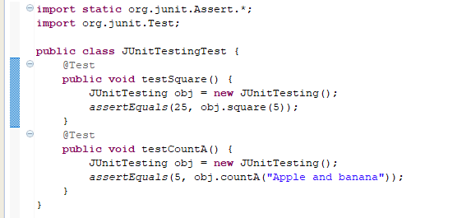
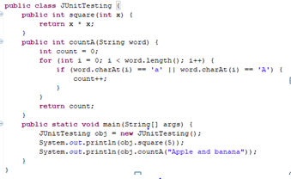
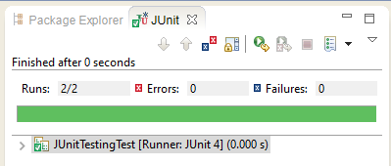
Output:
- Make new project, make a class. Add 2 methods in it. One method will find the max integer present in the input integer array. The other method will find the min integer. Now create test cases for both these methods and test your code. Follow all the steps as mentioned above in the manual.
Code:

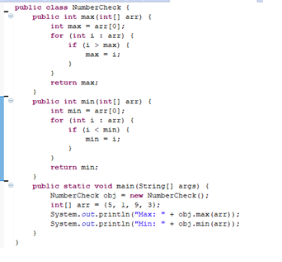

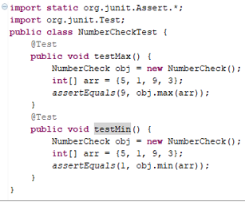
Output:
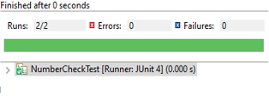
Github Screenshot:
